TITLE OF THE PAPER— UPPERCASE, BOLD, MAX 30 WORDS, 14-PT
First Author*¹, Second Author² and Third Author³
¹ Author’s Position, University/Institute/Organization, Country, e-mail: xx1@yy1.com
² Author’s Position, University/Institute/Organization, Country, e-mail: xx2@yy2.com
³ Author’s Position, University/Institute/Organization, Country, e-mail: xx3@yy4.com
*Corresponding Author

ABSTRACT
The paper will start with an Abstract. The abstract should describe key features of the paper, the methods used, the key results obtained, and the implications of the present study. The abstract should be limited to a maximum of 250–300 words including spaces and punctuation. The abstract should not contain any undefined abbreviations or unspecified references. The abstract and the keywords must be fully contained on the first page with the title and authors' names and affiliation.
Keywords: Provide 4–6 keywords, arranged alphabetically, separated by semicolons. The keywords must be relevant to the work presented and thus may help to search papers online with wider visibility.
- INTRODUCTION
Introduction of the paper should provide enough background information to make it clear why the study was undertaken and should clearly describe the objectives of the study. Appropriate referencing is mandatory to avoid plagiarism. A too-long introduction with repeated text and information is discouraged.

General Guidelines for Writing Conference Paper:
The title shall be centered with Times New Roman 14 pt, boldface, in capital letters. The names of the authors shall be in sentence case, Times New Roman 10 pt, with just initials and last name of each author, separated by commas. The affiliation of all authors shall be in capital letters, Times New Roman, 9pt italics. Please DO NOT use any salutation (e.g., Professor, Dr., Mr., Ms., etc.) with the authors’ names.

The corresponding/presenting author should be denoted by an asterisk (*) and should be placed after the author(s) affiliation/address with a space of 6 points before and 12 points after it. The affiliation/ address of the authors should follow the author list after a single line space.

The full paper must not exceed 12 (Twelve) pages or 6000 words on A4 format, including text, tables, figures, and references. Word files must be no more than 50 MB in file size to use the online submission system. Margins should be set as follows: Left, Right, Top, and Bottom: 2.54 cm. Use a Times New Roman font with 10 pt. for the text. All text must be single-spaced. We strongly recommend that all authors include their email addresses in their papers.

The following styles can be used to format the manuscript:
For Title | UPPERCASE, BOLD, MAX 30 WORDS, 14-PT
For Abstract & Acknowledgement | There will be a spacing of 12 pt before and 6 pt after.
For Section title | For example,  1. INTRODUCTION, there will be a spacing of 12 pt before and 6 pt after, and the title will be UPPERCASE and bold.
For sub-section titles | For example,  2.1 Land Use and Area Calculation: there will be a spacing of 6 pt before and 6 pt after, and the title will be written in ‘Capitalize Each Word’ and bold.  For instance,  2.1.1 Area Calculation: there will be a spacing of 6 pt before and 6 pt after, and the title will be written in ‘Capitalize Each Word’, italic and bold.
For the text | The font size of the text will be 10 points. There should be a space of 10 pt after each paragraph. The text should be justified.
File name | Rename this paper as PaperID_Full_Paper_ICIURP2027  For example, (46_Full_Paper_ICIURP2027)
Ethical Considerations | All submitted manuscripts will be screened for plagiarism and inappropriate use of artificial intelligence (AI). Any use of AI tools in manuscript preparation must be appropriately disclosed and acknowledged. Authors are responsible for the originality, accuracy, and integrity of their work.
References | Font size: 9 pt; at least 20 references are required

The preferred organization of the full paper is as follows:
Title, Author Names and Affiliations
Abstract
Introduction
Methodology
Results and Discussions
Conclusions
Acknowledgments
References
- METHODOLOGY
This section should describe the methodology developed, used, and/or modified scientifically with appropriate references (if necessary). The methodology of the paper should provide the reader with all the information necessary to repeat the work. For a modification of published methodology, only the modification needs to be described, with reference to the original source. Statistical analysis of the data (where applicable) is mandatory, using appropriate methods, which must be cited. The well-documented and published methods, if used, should be discussed very briefly with proper references.
- RESULTS AND DISCUSSIONS

  - Results
Results should be clear and concise. The data presented in Tables should not be repeated in Figures unless they may differ significantly and are necessary to understand the outcomes.
  - Discussions
Discussion should explore the significance of the results of the work and, when appropriate, compare them to the outcomes of studies elsewhere. The real-world application of your work or research should be stated and explained in this part. The limitations of the study can also be discussed here if necessary. A minimum of 500 words of discussion is encouraged.
- CONCLUSION
The conclusion section briefly summarizes the work presented with specific conclusions achieved in line with objectives of the study. A brief implication of the study can also be put at the end.

ACKNOWLEDGEMENT (if any)
Write acknowledgements in a separate section at the end of the article before the references, if any. List here those individuals who provided help during the research.

APPENDIX (if any)
Provide the appendix in a separate section at the end of the article before the references, if any. List here those supplementary tables or figures used in this research.

REFERENCES
Please observe the following guidelines: APA 7th edition should be followed for preparing the reference list, while numbered citations in square brackets should be used for in-text citations. Please observe the following guidelines: · Single citation: [9] · Multiple citations: [4-6, 9,15]. The reference numbers should correspond to the order in which the sources are first cited in the text. Thus, the first cited reference should be numbered [1], the second [2], and so forth. Once a reference has been assigned a number, the same number should be used whenever that source is cited again. Sequential citation by order of citation: Reference [7] should not be cited before reference [5] has been introduced.

References should be listed numerically according to their first appearance in the text, not alphabetically. However, each individual reference should be formatted according to the APA 7th edition style. Authors should include the DOI of a publication whenever available and present it in the format https://doi.org/xxxxx. Only references directly related to the paper should be included. Authors are strongly encouraged to use reference-management software such as Mendeley, Zotero, or EndNote and select an appropriate numbered citation style that produces citations in square brackets while ensuring that the reference entries themselves are formatted consistently with APA 7th edition requirements. At least 20 references must be included in your conference paper (references from recognized journals should be focused); Font size for references: 9 pt.

Examples of APA 7th Edition References

Journal article:
[1] Lambin, E. F., Turner, B. L., Geist, H. J., Agbola, S. B., Angelsen, A., Bruce, J. W., Coomes, O. T., Dirzo, R., Fischer, G., Folke, C., George, P., Homewood, K., Imbernon, J., Leemans, R., Li, X., Moran, E. F., Mortimore, M., Ramakrishnan, P. S., Richards, J. F., Xu, J. (2001). The causes of land-use and land-cover change: Moving beyond the myths. Global Environmental Change, 11(4), 261–269. https://doi.org/10.1016/S0959-3780(01)00007-3

Chapter in an edited book:
[2] Healey, P. (2006). Transforming governance: Challenges of institutional adaptation. In M. Tewdwr-Jones & P. Allmendinger (Eds.), Territory, identity and spatial planning (pp. 3–18). Routledge.

Conference proceedings paper:
[3] Smith, J. A., & Rahman, M. (2024). Sustainable urban development in rapidly growing cities. In Proceedings of the International Conference on Sustainable Urban Development (pp. 125–132). Publisher Name. https://doi.org/xxxxx

Conference paper:
[4] Hasan, M. R. (2025, January 15–17). Climate-resilient land-use planning in coastal Bangladesh [Paper presentation]. International Conference on Urban Resilience, Dhaka, Bangladesh.

Newspaper article:
[5] Rahman, S. (2025, March 10). Bangladesh cities face growing pressure from rapid urbanization. The Daily Star. https://www.thedailystar.net/xxxxx

Website:
[6] United Nations. (2023). Sustainable development goals. https://www.un.org/sustainabledevelopment/

Report:
[7] World Bank. (2023). Bangladesh country climate and development report. World Bank. https://www.worldbank.org/xxxxx

Thesis/Dissertation:
[8] Rahman, M. A. (2024). Assessing urban resilience in coastal cities of Bangladesh [Master's thesis, University Name]. University Repository.

Figures and Tables
It is essential that all illustrations are clear and legible. Vector graphics (rather than rasterized images) should be used for diagrams and schemas whenever possible. Please check that the lines in line drawings are not interrupted and have a constant width. Grids and details within the figures must be clearly legible and may not be written one on top of the other. Figures and Tables should be cross-referenced in the text.

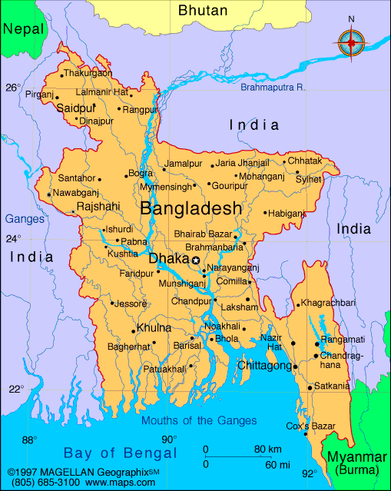
Figure 1: Map of Bangladesh (font size: 10 pt)
(Source: If any; font size: 9 pt)

Figures should be presented in the order mentioned in the text and labeled in consecutive Arabic numerals as [Fig. 1]. For example: The map has certain colors [Fig. 1]. At the beginning of any sentence, it will be as follows. Figure 1 shows that the map of Bangladesh has certain rivers.
The final size of figures should be fitted within the page margins. Figures should be placed into the text appropriately and with the position and wrap text set to “In line with text”. The following resolutions are optimal: black & white line figures- 600 dpi; photographs- 300 dpi; screen dumps- leave as is. We encourage preparing the figures in EPS or TIFF format, but you can also use high-quality BMP or JPG format.

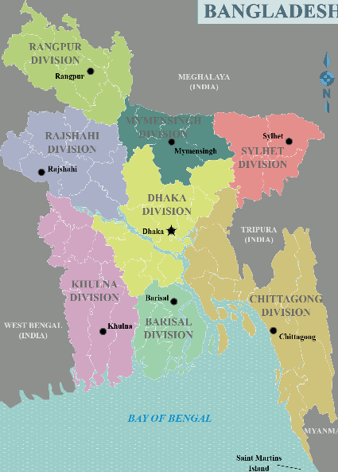 | 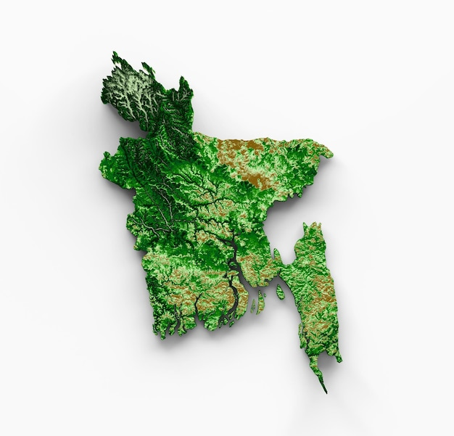
Figure 2: Map of Bangladesh | Figure 3: Topographic Map of Bangladesh
(Source: If any; font size: 9 pt) | (Source: If any; font size: 9 pt)

Tables should be typed in the text appropriately, numbered consecutively with Arabic numerals like Table 1, Table 2, etc., and fitted within page margins. All lettering should be done using standard fonts; tables should be self-explanatory and include a brief descriptive title. Footnotes to tables indicated by lower-case superscript letters are acceptable, but they should not include extensive experimental detail. Do not fit the table in text as a figure.

Table 1: Name and Description of Various Consumers
Sl. No | Name | Description | Mobile No.
1 | X | Mr. X is ….. and he is …… years old. Also, he has some positive qualities | 018XXXXXXX
2 | Y | Mr. Y is ….. and he is …… years old. Also, he has some positive qualities | 018XXXXXXX
3 | Z | Mr. Z is ….. and he is …… years old. Also, he has some positive qualities | 019XXXXXXX
(Source: If any; font size: 9 pt)

This is how the table should be prepared, including a table title and proper formatting.
Equations
Number the equations consecutively with equation numbers in parentheses, as in

${\left(x+a\right)}^{n}=\sum_{k=0}^{n}{\left({n \atop k}\right)x^{k}a^{n-k}}$ (1)

Refer to “Eq. (1)” except at the beginning of a sentence, like “Equation [1] is ... …

